Case records of the JANAAN HEALTH
A patient based learning methods
With further references and reading links.

Date of the case:12/12/2016
Case presentation:

A 70 years old gentleman was referred by spinal surgeons to exclude lymphoma and/or myeloma having found abnormal MRI signal and small volume mediastinal lymph node on CT scan.
He has persistent hypercalcemia since August 2016 , Calcium 3.18, low PTH 0.56
He was reviewed in haematology clinic and underwent several investigation includes :
In Sept 2016 he underwent Bone marrow aspirate and trephine, showed no infiltrations X2
Normal immunoglobulins, no monoclonal band and normal SFLC.
Mildly anaemic with HB110, Alk Phos 344 PSA normal ACE normal
Skeletal Survey + Bone Scan: non- contributory.
He was not on any medications or over the counter drugs apart from NSAID and paracetamol.

No family history of notes.
In October 2016 he had PET CT - minor mediastinal adenopathy, and highly avid spleen.
He was then reviewed by respiratory to obtain biopsy by EBUS, which was non diagnostic.
He was also reviewed in endocrine and Cancer of Unknown primary clinics.
Meanwhile he was treated with intermittent Zolindronic acid and fluid.

.
Investigations liquids:
ALP 184, corrected calcium 2.69, sodium 134, potassium 4.6, urea 7.9, creatinine 116, Hb 92, WCC 6.6, platelets 275, neutrophils 4.53, LFT normal.
Serum PTH 0.56 (low), serum protein electrophoresis normal, serum free light chain ratio normal, Beta 2 microglobulin normal. Bence Jones protein negative. Vitamin B12, folate, ferritin negative. Carcinoembryonic antigen negative.
Serum ACE low on two separate occasions (28th September and 4th October 2016)

Histology slides: not added

Scans:

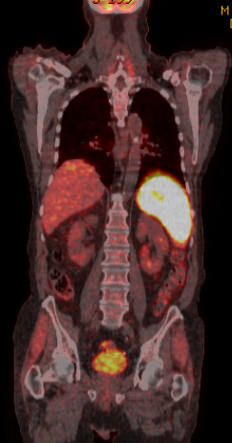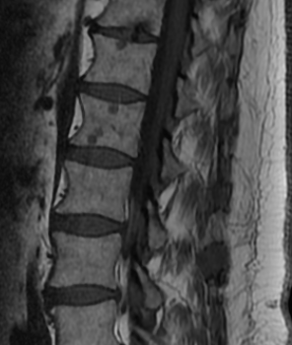

PET Avid Spleen MRI Abnormal marrow signal

Differential diagnosis suggested:

Hypercalcemia secondary to

Myeloma
Lymphoma
Other primaries
Metastatic cancer of Unknown primaries (CUP)

Clinical diagnosis:
Hypercalcemia secondary to Lymphoma

Further investigations:

He was then referred to secondary centre for splenic biopsy.
Revealed non-caseating granulomatous lesions highly likely to be Sarcoidosis.
ZN stain negative

Final diagnosis:
Hypercalcemia secondary to Sarcoidosis with adenoptahy and bony involvement

Discussions:
This is a very challenging case of Hypercalcemia. Required multi specialties in put until the final diagnosis made.
Hypercalemia is not uncommon in haematological and non-haematological malignancies
Usually clinical history and primary investigations are conclusive
Hypercalcemia associated with neuroendocrine tumours and ectopic paraneoplastic manifestations required multi-disciplinary input occasionally.

In our case low PTH and high Calcium raised the possibilities of ectopic PTHRP secretion and this has been excluded by our endocrine team

Further reading as below paper

PTH-Related Peptide (PTHrP) in Hypercalcemia
- Gregory R. Mundy and
- James R. Edwards
+ Author Affiliations
- Vanderbilt Center for Bone Biology, Division of Clinical Pharmacology, Department of Medicine, Vanderbilt University, Nashville, Tennessee
- Correspondence:
Dr. Gregory R Mundy, Vanderbilt Center for Bone Biology, 1235 Medical Research Building IV, Nashville, TN 37232-0575. Phone: 615-322-6110; Fax: 615-343-2611; E-mail: gregory.r.mundy@vanderbilt.edu

[Hypercalcemia in sarcoidosis--case report, prevalence, pathophysiology and therapeutic options].
[Article in German]
Ackermann D¹.

Author information
- ¹Klinik für Nephrologie und Hypertonie, Universitätsspital Bern. Daniel.Ackermann@insel.ch

Abstract
Hypercalcemia is a highly prevalent complication of sarcoidosis. A medical history of a patient with sarcoidosis is shown as case report. Depending on the population studied about 2-63% of sarcoidosis patients show hypercalcemia. The major difference in the prevalence of hypercalcemia may be in part due to the undulating course of subacute sarcoidosis, so hypercalcemia may be missed when serum calcium is not frequently measured. Hypercalciuria appears to be twice as prevalent then hypercalcemia and should be looked for in every sarcoidosis patient. Hypercalcemia in sarcoidosis is due to the uncontrolled synthesis of 1,25-dihydroxyvitamin D3 by macrophages. 1,25-dihydroxyvitamin D3 leads to an increased absorption of calcium in the intestine and to an increased resorption of calcium in the bone. Immunoregulatory properties have been ascribed to 1,25-dihydroxyvitamin D3. It is an important inhibitor of interleukin-2 and of interferon-gamma-synthesis, two cytokines that are important in granuloma formation in sarcoidosis. It is thought that 1,25-dihydroxyvitamin D3 counterregulates uncontrolled granuloma formation. Treatment of hypercalcemia depends on the serum level of hypercalcemia and its persistence. Generally sarcoidotic patients should be advised to avoid sun exposition to reduce vitamin D3 synthesis in the skin, to omit fish oils that are rich of vitamin D and to produce more than two liters urine a day by adapting fluid intake. Although severe hypercalcemia seems to be rare, glucocorticosteroid treatment should be started if corrected total calcium level rises beyond 3 mmol/l. If hypercalcemia is symptomatic, treatment should be started even at lower levels. Glucocorticosteroids act by inhibition of the overly 1alpha-hydroxylase activity of macrophages. Alternatively, treatment with chloroquine or ketoconazole can be established. If isolated hypercalciuria without hypercalcemia is present with evidence for recurrent nephrolithiasis, patients can be treated with a thiazide diuretic

Conclusions:
Hypercalcemia is straight forward most of the time but rarely a challenge as In our case
Retrospective case notes review revealed this patient had history of bilateral anterior uveitis few years back and intermittent dry cough for many years

Learning points:
Review case notes for symtomptomatology
Serum ACE is non-diagnostic
Ask a friend early
There is always someone on the other side waiting to help for best outcome of our patients.

Please Do ask

